

Dokumentimi Kapitulli2

**Primitive Types and Variables**

Prof:Musafer Shala

Ass:Laberion Zebica Student:Albion Burrniku

Kampusi:FERIZAJ

1. **Declare several variables** by selecting for each one of them the most appropriate of the types **sbyte**, **byte**, **short**, **ushort**, **int**, **uint**, **long** and **ulong** in order to assign them the following values: 52,130; -115; 4825932; 97; -10000; 20000; 224; 970,700,000; 112; -44; -1,000,000; 1990; 123456789123456789.

class Program

{

static void Main()

{

ushort number1 = 52130;

sbyte number2 = -115;

uint number3 = 4825932;

byte number4 = 97;

short number5 = -10000;

short number6 = 20000;

byte number7 = 224;

uint number8 = 970700000;

sbyte number9 = 112;

sbyte number10 = -44;

int number11 = -1000000;

ushort number12 = 1992;

long number13 = 123456789123456789;

}

}

1. Which of the following values can be assigned to variables of type **float**, **double** and **decimal**: 5, -5.01, 34.567839023; 12.345; 8923.1234857; 3456.091124875956542151256683467?

class Program

{

static void Main()

{

double number1 = 34.567839023;

float number2 = 12.345f;

double number3 = 8923.1234857;

decimal number4 = 3456.091124875956542151256683467m;

}

}

1. Write a program, which **compares correctly** **two real numbers** with accuracy at least **0.000001**.

using System;

namespace detyra3

{

class Program

{

static void Main()

{

decimal number1 = 5.25745243896m;

decimal number2 = 9.8544531763m;

number1 += number2;

Console.WriteLine(number1.ToString("#.######"));

}

}

}

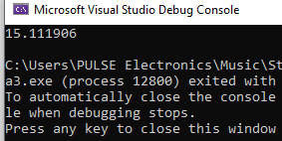

1. **Initialize** a variable of type **int** with a value of 256 in  
   **hexadecimal** format (256 is 100 in a numeral system with base 16).
2. Declare a variable of type **char** and assign as a value the character, which has **Unicode** code, 72 (use the Windows calculator in order to find hexadecimal representation of 72).
3. Declare a variable **isMale** of type **bool**and assign a value to it depending on your gender.

using System;

namespace detyra6

{

class isMale

{

static void Main(string[] args)

{

bool isMale = true;

}

}

}

1. Declare two variables of type **string** with values "Hello" and "World". Declare a variable of type **object**. Assign to this variable the value obtained of concatenation of the two string variables (add space if necessary). Print the variable of type **object**.

using System;

namespace detyra7

{

class Program

{

static void Main(string[] args)

{

string str1 = "Hello";

string str2 = "World";

object obj = str1 + " " + str2;

}

}

}

1. Declare two variables of type **string** and assign them values "Hello" and "World". Declare a variable of type **object** and assign to it the value obtained of concatenation of the two variables of type **string** (do not miss the space in the middle). Declare a third variable of type **string** and initialize it with the value of the variable of type **object** (you should use type casting).

using System;

namespace detyra8

{

class Program

{

static void Main(string[] args)

{

string str1 = "Hello";

string str2 = "World";

object obj = str1 + " " + str2;

string str3 = obj.ToString();

}

}

}

1. Declare two variables of type **string** and assign them a value “**The "use" of quotations causes difficulties.**” (without the outer quotes). In one of the variables use quoted string and in the other do not use it.

class Program  
{  
    static void Main(string[] args)  
    {  
        string str1 = "The \"use\" of quotations causes difficulties.";          
        string str2 = "The " + "\u0022" + "use" + "\u0022" + " of quotations causes difficulties";  
    }  
}

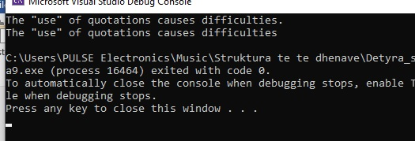

1. Write a program to print a figure in the shape of a **heart** by the sign "**o**".

using System;

namespace detyra10

{

class Program

{

static void Main(string[] args)

{

Console.WriteLine(" 0 0 ");

Console.WriteLine("0 0 0 0");

Console.WriteLine(" 0 0 0 0");

Console.WriteLine(" 0 00 0");

Console.WriteLine(" 0 0 ");

Console.WriteLine(" 0 0 ");

Console.WriteLine(" 0 0 ");

Console.WriteLine(" 00 ");

}

}

}

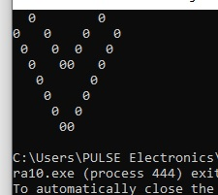

1. Write a program that prints on the console **isosceles triangle** which sides consist of the copyright character "**©**".

using System;

namespace detyra11

{

class Program

{

static void Main(string[] args)

{

Console.WriteLine(" ©");

Console.WriteLine(" © ©");

Console.WriteLine(" © ©");

Console.WriteLine(" © ©");

Console.WriteLine(" ©©©©©©©©");

}

}

}

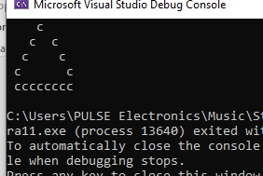

1. A company dealing with marketing wants to keep a data record of its **employees**. Each record should have the following characteristic – first name, last name, age, gender (‘m’ or ‘f’) and unique employee number (27560000 to 27569999). **Declare appropriate variables** needed to maintain the information for an employee by using the appropriate data types and attribute names.

using System;

namespace detyra12

{

class Program

{

static void Main(string[] args)

{

string firstName;

string lastName;

byte age;

char gender;

int id;

}

} }

1. Declare two variables of type **int**. Assign to them values 5 and 10 respectively. **Exchange (swap) their values** and print them.

using System;

namespace detyra13

{

class Program

{

static void Main(string[] args)

{

int a = 2;

int b = 3;

a = a + b;

b = a - b;

a = a - b;

Console.WriteLine("a:{0} b:{1}", a, b);

}

}

}

